H.T No
Regulations:
A20

Sreenidhi Institute of Science and Technology
(An Autonomous Institution)
Code No:8A304 Date: 13-September-2024 (FN)

B.Tech II-Year I- Semester External Examination, September-2024 (Supplementary)
ELECTRICAL CIRCUITS AND NETWORKS-II(EEE)

Time: 3 Hours Max.Marks:70

Note: a) No additional answer sheets will be provided.
b) All sub-parts of a question must be answered at one place only, otherwise it will not be valued.
c) Missing data can be assumed suitably.

Bloom's Cognitive Levels of Learning (BCLL)

Remember | L1 | Apply | L3 | Evaluate | L5
Understand | L2 | Analyze | L4 | Create | L6

Part - A Max.Marks:20
Answer all QUESTIONS

 |  | BCLL | CO(s) | Marks
1 | What are the advantages of a poly phase system over a single phase system | L1 | CO1 | [2M]
2 | List any two differences between classical and Laplace transform methods of solution of the network | L1 | CO2 | [2M]
3 | What is the significance of poles in the transfer function? | L1 | CO3 | [2M]
4 | List ABCD parameters interms of H-parameters. | L1 | CO4 | [2M]
5 | Draw the frequency response characteristics of low pass filter. | L1 | CO5 | [2M]
6 | List advantages of Fourier transform? | L1 | CO6 | [2M]
7 | why the current in a pure inductance cannot change in zero time. | L2 | CO1 | [2M]
8 | What is a driving point function? | L1 | CO3 | [2M]
9 | Write short notes on Line spectra | L1 | CO5 | [2M]
10 | What is the relationship between line and phase quantities in a 3-phase Delta connected system. | L1 | CO6 | [2M]
Part – B Max.Marks:50
ANSWER ANY FIVE QUESTIONS. EACH QUESTION CARRIES 10 MARKS.

 |  |  | BCLL | CO(s) | Marks
11. | a) | Show that two wattmeters are sufficient to measure power in a 3-phase circuit. Derive the expressions for wattmeter readings for a balanced 3-phase load. | L2 | CO1 | [5M]
 | b) | Three impedances of ( 7 +j4) Ω, ( 3 +j2) Ω and ( 9 +j2) Ω are connected between neutral and the R, Y and B phases. The line voltage is 440 V. Calculate The line currents. | L4 | CO1 | [5M]
12. | a) | A D.C voltage of 20 V is applied in a R-L circuit where R = 50 Ω and L = 10 H. Find,  (i) The time constant  (ii) The maximum value of stored energy. | L2 | CO2 | [5M]
 | b) | Derive an expression for the current response In RL series circuit with a sinusoidal source. | L3 | CO2 | [5M]
13. | a) | Find the transform impedance of the following circuit shown in figure.  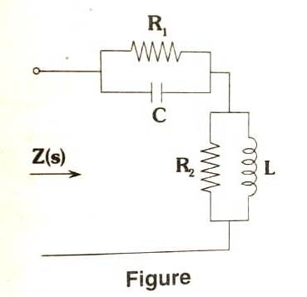 | L3 | CO3 | [5M]
 | b) | What is a transfer function? Explain the necessary conditions for transfer functions. | L2 | CO3 | [5M]
14. | a) | Find the transmission parameters of the network shown in figure.  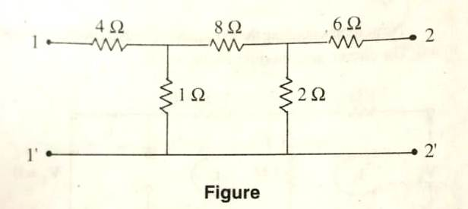 | L2 | CO4 | [5M]
 | b) | Find the Y-parameters for the following network (figure).  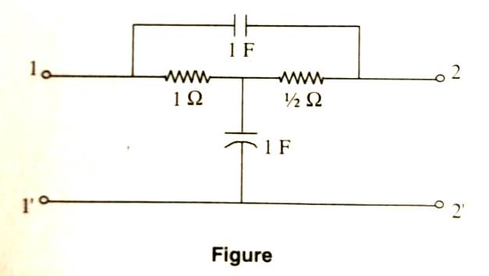 | L2 | CO4 | [5M]
15. | a) | Derive the characteristic impedance of T-section constant –K low pass filter. | L2 | CO5 | [5M]
 | b) | Classify the filters according to their,  (i) Frequency characteristic and  (ii) Depending upon the relation between series impedance and shunt impedance. | L3 | CO5 | [5M]
16. | a) | Explain the types of symmetry in Fourier analysis. | L2 | CO6 | [5M]
 | b) | Find the Fourier transform of the exciting voltage  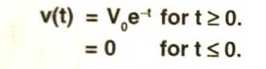  Sketch approximately amplitude and phase spectra. | L2 | CO6 | [5M]
17. | a) | Three identical impedances of (3+4j) ohms are connected in delta. Find an equivalent star network such that the line current is the same when connected to the same supply. | L3 | CO1 | [4M]
 | b) | What is the significance of time constant of R-L circuit? And define time constant for R-L circuit? | L3 | CO2 | [3M]
 | c) | Draw the pole-zero plots for a system with following network function.  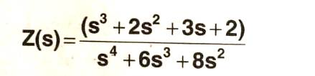 | L3 | CO3 | [3M]
18. | a) | Express z-parameters in terms of h-parameters and ABCD parameters. | L2 | CO4 | [4M]
 | b) | Write short notes on m-derived low pass filter. | L2 | CO5 | [3M]
 | c) | State the following properties of Fourier transform:  (i) Linearity property  (ii) Symmetry property  (iii) Scaling property. | L2 | CO6 | [3M]
-- 00 -- 00 –

